

Informatics College Pokhara



Programming

CS4001NP

Coursework 1

|  |  |  |
| --- | --- | --- |
| Submitted By: |  | Submitted To: |
| Student Name: | Janak Devkota | Mr. Sushil Paudel |
| London Met ID: | 23048806 | Module Leader |
| Group: | CC4057 | Programming |
| Date: | 23-Jan-2024 |  |

Table of Contents

1. INTRODUCTION 1

2. Class Diagram 2

2.1) Teacher class: 2

2.2) Lecturer class: 3

2.3) Tutor class: 4

3. Pseudocode 7

3.1) Pseudocode for Teacher class: 7

3.2) Pseudocode for Lecturer class: 9

3.3) Pseudocode for Tutor class: 13

4. Method Description 16

4.1) Methods in Class Teacher 17

4.2) Methods in Class Lecturer 18

4.3) Methods in Class Tutor 18

5. Testing 20

5.1) Test 1: 20

5.2) Test 2: 23

5.3) Test 3: 26

Test 4: 29

4.1 Displaying the lecturer Class 29

4.2 Displaying the Tutor Class 32

6.Error Detection and Error correction 35

6.1 Syntax Error 35

6.2 Runtime Error 35

6.3 Logical Error 37

7.Conclusion 38

7.References 39

8.Appendix 40

**Table of Figures**

Figure 1: Teacher class 2

Figure 2: Lecturer Class 3

Figure 3: Tutor class 4

Figure 4: Class Diagram 5

Figure 5: Inserting values to Lecturer object 21

Figure 6: Inspecting the Lecturer Class before setting the GradedScore 21

Figure 7: Setting the Graded Score 22

Figure 8: Output after setting the Graded Score 22

Figure 9: Inspecting the Lecturer Class After setting the GradedScore 22

Figure 10: Inserting values to Tutor object 24

Figure 11: Inspecting the Tutor class before setting the Salary 24

Figure 12: Assigning the Tutor Class for salary 25

Figure 13: inspecting the Tutor Class After setting salary 25

Figure 14: Creating the object of Tutor Class 27

Figure 15: inspecting the Tutor Class before Removing Tutor 27

Figure 16: message After running the RemoveTutor method 28

Figure 17: Reinspecting the Tutor Class After Removing Tutor 28

Figure 18: creating object for lecturer 30

Figure 19: inserting values for gradeAssignment 30

Figure 20: Calling the display() method 31

Figure 21: Displaying the Lecturer class 31

Figure 22: Creating an object for Tutor class 33

Figure 23: inserting values for setSalary 33

Figure 24: Calling the display() method 34

Figure 25: Displaying the Tutor class 34

Figure 26: Syntax Error 35

Figure 27: Syntax Error Correction 35

Figure 28: Runtime error detection while execution 36

Figure 29: : Runtime Error Detection 36

Figure 30: error correction 36

Figure 31: output After the Logical Error 37

Figure 32: Logical Error 37

Figure 33: Correction of Logical Error 37

**Table of Tables**

Table 1: Table of lecturer for test 1 20

Table 2: Table of Tutor for test 2 23

Table 3: Table of Tutor for test 3 26

Table 4: Table of Lecturer for test 4.1 29

Table 5: Table of Tutor for test 4.2 32

# INTRODUCTION

This report is about my first assignment in the Programming class, and it's a really important part of my overall grade—30% important! I decided to use Java for this task because it's known for being friendly to people who are just starting to learn programming. (Kölling, 2004) The assignment was a significant challenge given by the module leader, and it was a big deal for my overall grade. I dove into it, opting for Java as my programming language. The actual coding part was made easier with the help of a tool called BlueJ. It is friendly playground for code. It gave me a nice space to write my code and see how it works. This made the whole process much less scary and more like a fun adventure.

As I started working on the assignment, I began to understand Java better. It's like learning a new language, but instead of words, you use code. Writing and running the code wasn't just about finishing the assignment; it was like solving little puzzles and fixing mistakes. Each mistake taught me something new, like how to make my code better and avoid problems in the future. Java turned out to be full of twists and turns, like an exciting journey. It has its own set of rules and tricks, and I had to figure them out. Despite the challenges, the whole experience was surprisingly enjoyable. It was a mix of difficulty and fun, showing me that learning to code can be both tough and rewarding.

In the end, this report is like telling the tale of my first coding adventure in the Programming class. Choosing Java and using BlueJ made it less intimidating, and the challenges turned into opportunities to learn and grow. (Kölling, 2004) This journey showed me that coding is not just about getting things right; it's about enjoying the process and becoming better with every step.

# 2. Class Diagram

### 2.1**) Teacher class:**

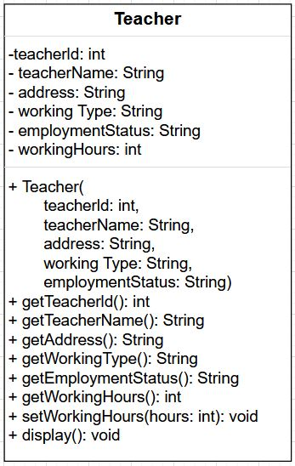

Figure 1: Teacher class

The class diagram for the "Teacher" class defines attributes like teacherId, teacherName, address, workingType, employmentStatus, and workingHours. It includes methods (getters and setters) for accessing and modifying these attributes, facilitating object-oriented management and manipulation of teacher data in a program.

### **2.2) Lecturer class:**

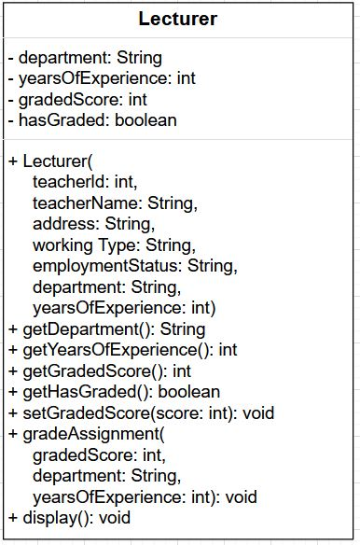

Figure 2: Lecturer Class

The extended "Lecturer" class introduces additional attributes: department, yearsOfExperience, gradedScore, and hasGraded. It includes methods like getDepartment, getYearsOfExperience, getGradedScore, getHasGraded, setGradedScore, gradeAssignment, and display, tailored for lecturers' unique responsibilities. This extension enhances the object-oriented framework, addressing specific lecturer requirements and functionalities.

### **2.3) Tutor class:**

Figure 3: Tutor class

The "Tutor" class expands upon "Teacher" and "Lecturer," featuring attributes such as salary, specialization, academic qualifications, performance index, and isCertified. Accompanying methods include getSalary, getSpecialization, getAcademicQualifications, getPerformanceIndex, isCertified, setSalary, removeTutor, and display. This design caters to the intricate demands of managing tutoring personnel within an object-oriented paradigm, addressing real-world complexities while adhering to modularity and reusability principles. The setSalary method facilitates dynamic adjustments based on performance, hours worked, and certification status. The removeTutor method provides flexibility, allowing the removal of tutors when needed. This comprehensive template ensures effective representation and interaction with tutor instances in software systems. Feel free to inquire about specific implementation details or further clarification.

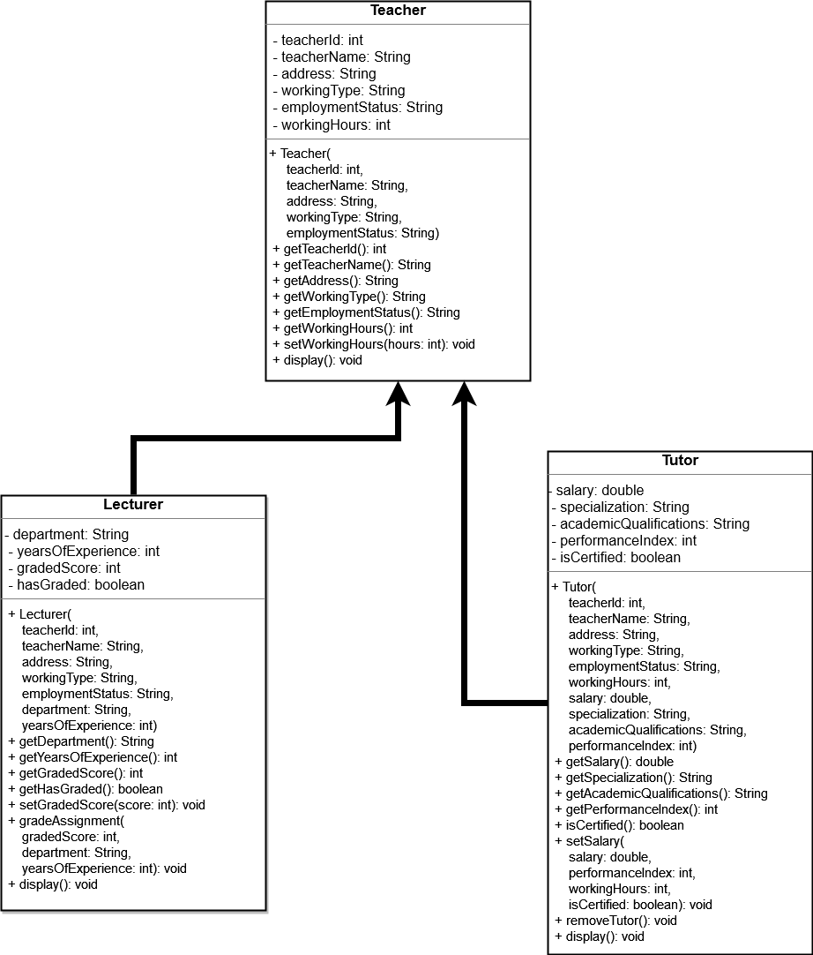

Figure 4: Class Diagram

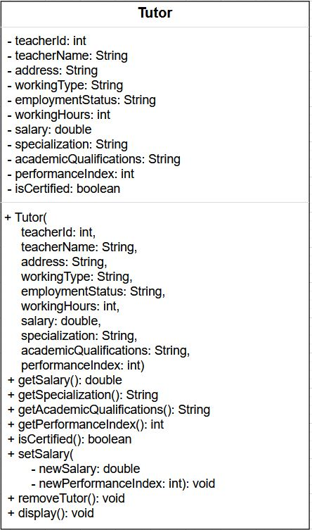

This program features a hierarchical class structure comprising three classes: Teacher, Lecturer, and Tutor. In this design, Teacher acts as the superclass, while Lecturer and Tutor serve as its subclasses. This arrangement exemplifies hierarchical inheritance, showcasing a logical relationship where both Lecturer and Tutor inherit attributes and behaviour’s from the more generalized Teacher class. The class diagram visually represents the relationships and elements within these classes. It illustrates the methods and variables associated with each class, providing a clear overview of their functionalities. Emphasis is placed on the utilization of getter and setter methods. These methods play a pivotal role in accessing and modifying private instance variables, ensuring controlled and secure manipulation of class-specific data. (Singh, 2012)

In summary, the class diagram encapsulates the hierarchical inheritance structure, showcasing the relationships and attributes of Teacher, Lecturer, and Tutor classes. The strategic use of getter and setter methods underlines the program's commitment to encapsulation, promoting a well-organized and efficient approach to handling private instance variables.

# 3. Pseudocode

Pseudocode is a simple plan for a computer program. It uses basic English phrases instead of complex code words. It's like a list of steps with arrows to show repeating actions. Indentation helps organize the flow. It saves time in coding and helps people understand the program. Some projects use only pseudocode, others use both flow charts and pseudocode. (Toulson, 2017)

### **3.1) Pseudocode for Teacher class:**

START PROGRAM Teacher AS PARENT

DECLARE PRIVATE VARIABLE int teacherId

DECLARE PRIVATE VARIABLE string teacherName

DECLARE PRIVATE VARIABLE string address

DECLARE PRIVATE VARIABLE string workingType

DECLARE PRIVATE VARIABLE string employmentStatus

DECLARE PRIVATE VARIABLE int workingHours

DECLARE CONSTRUCTOR Teacher with teacherId, teacherName, address, workingType, employmentStatus AS PARAMETERS

ASSIGN teacherId VALUE IN INSTANCE VARIABLE teacherId

ASSIGN teacherName VALUE IN INSTANCE VARIABLE teacherName

ASSIGN address VALUE IN INSTANCE VARIABLE address

ASSIGN workingType VALUE IN INSTANCE VARIABLE workingType

ASSIGN employmentStatus VALUE IN INSTANCE VARIABLE employmentStatus

END CONSTRUCTOR Teacher

DECLARE METHOD getTeacherId WITH RETURN TYPE int

RETURN teacherId

END METHOD getTeacherId

DECLARE METHOD getTeacherName WITH RETURN TYPE STRING

RETURN teacherName

END METHOD getTeacherName

DECLARE METHOD getAddress WITH RETURN TYPE STRING

RETURN address

END METHOD getAddress

DECLARE METHOD getWorkingType WITH RETURN TYPE STRING

RETURN workingType

END METHOD getWorkingType

DECLARE METHOD getEmploymentStatus WITH RETURN TYPE STRING

RETURN employmentStatus

END METHOD getEmploymentStatus

DECLARE METHOD getWorkingHours WITH RETURN TYPE INT

RETURN workingHours

END METHOD getWorkingHours

DECLARE VOID METHOD setWorkingHours WITH hours AS PARAMETER

ASSIGN hours VALUE IN INSTANCE VARIABLE workingHours

END METHOD setWorkingHours

DECLARE VOID METHOD DISPLAY

PRINT "Teacher ID: " + teacherId

PRINT "Teacher Name: " + teacherName

PRINT "Address: " + address

PRINT "Working Type: " + workingType

PRINT "Employment Status: " + employmentStatus

START IF STATEMENT

IF workingHours > 0 THEN

PRINT "Working Hours: " + workingHours

ELSE

PRINT "Working Hours have not been assigned yet."

END IF

END IF

END PROGRAM Teacher

### **3.2) Pseudocode for Lecturer class:**

START PROGRAM Lecturer AS CHILD OF Teacher

DECLARE PRIVATE VARIABLE string department

DECLARE PRIVATE VARIABLE int yearsOfExperience

DECLARE PRIVATE VARIABLE int gradedScore

DECLARE PRIVATE VARIABLE boolean hasGraded

DECLARE CONSTRUCTOR Lecturer with teacherId, teacherName, address,

workingType, employmentStatus, department, yearsOfExperience AS PARAMETERS

CALL SUPERCLASS CONSTRUCTOR Teacher with teacherId, teacherName, address,

workingType, employmentStatus

ASSIGN department VALUE IN INSTANCE VARIABLE department

ASSIGN yearsOfExperience VALUE IN INSTANCE VARIABLE yearsOfExperience

ASSIGN gradedScore VALUE 0 IN INSTANCE VARIABLE gradedScore

ASSIGN hasGraded VALUE false IN INSTANCE VARIABLE hasGraded

CALL SUPERCLASS METHOD setWorkingHours WITH 0 AS PARAMETER

END CONSTRUCTOR Lecturer

DECLARE METHOD getDepartment WITH RETURN TYPE STRING

RETURN department

END METHOD getDepartment

DECLARE METHOD getYearsOfExperience WITH RETURN TYPE INT

RETURN yearsOfExperience

END METHOD getYearsOfExperience

DECLARE METHOD getGradedScore WITH RETURN TYPE INT

RETURN gradedScore

END METHOD getGradedScore

DECLARE METHOD getHasGraded WITH RETURN TYPE BOOLEAN

RETURN hasGraded

END METHOD getHasGraded

DECLARE VOID METHOD setGradedScore WITH score AS PARAMETER

ASSIGN score VALUE IN INSTANCE VARIABLE gradedScore

END METHOD setGradedScore

START METHOD gradeAssignment WITH PARAMETERS gradedScore, department, yearsOfExperience

START IF STATEMENT

IF yearsOfExperience >= 5 AND this.department EQUALS department THEN

START IF STATEMENT

IF gradedScore LESS THAN OR EQUAL TO 0 OR gradedScore GREATER THAN OR EQUAL TO 100 THEN

PRINT "Out of range grading score. Must be between 1 and 100."

ELSE

// Grading logic

START IF-ELSE CHAIN

IF gradedScore >= 70 THEN

PRINT "Grade: A"

ELSE IF gradedScore >= 60 THEN

PRINT "Grade: B"

ELSE IF gradedScore >= 50 THEN

PRINT "Grade: C"

ELSE IF gradedScore >= 40 THEN

PRINT "Grade: D"

ELSE

PRINT "Grade: E"

END IF-ELSE CHAIN

// Update gradedScore and hasGraded

this.gradedScore = gradedScore

this.hasGraded = true

END IF

END IF STATEMENT

ELSE

// Display a suitable message when assignments have not been graded.

PRINT "Assignments have not been graded."

END IF

END IF STATEMENT

END METHOD gradeAssignment

OVERRIDE METHOD display

CALL SUPERCLASS METHOD display

PRINT "Department: " + department

PRINT "Years of Experience: " + yearsOfExperience

START IF STATEMENT

IF hasGraded THEN

PRINT "Graded Score: " + gradedScore

ELSE

PRINT "This Lecturer has not graded any assignment yet."

END IF

END IF

END METHOD display

END PROGRAM Lecturer

### **3.3) Pseudocode for Tutor class:**

START PROGRAM Tutor AS CHILD OF Teacher

START PROGRAM Tutor AS CHILD OF Teacher

DECLARE PRIVATE VARIABLE double salary

DECLARE PRIVATE VARIABLE string specialization

DECLARE PRIVATE VARIABLE string academicQualifications

DECLARE PRIVATE VARIABLE int performanceIndex

DECLARE PRIVATE VARIABLE boolean isCertified

DECLARE CONSTRUCTOR Tutor WITH teacherId, teacherName, address, workingType, employmentStatus,

workingHours, salary, specialization, academicQualifications, performanceIndex AS PARAMETERS

CALL SUPERCONSTRUCTOR Teacher WITH teacherId, teacherName, address, workingType, employmentStatus AS ARGUMENTS

CALL setWorkingHours METHOD WITH workingHours AS ARGUMENT

ASSIGN salary VALUE IN INSTANCE VARIABLE salary

ASSIGN specialization VALUE IN INSTANCE VARIABLE specialization

ASSIGN academicQualifications VALUE IN INSTANCE VARIABLE academicQualifications

ASSIGN performanceIndex VALUE IN INSTANCE VARIABLE performanceIndex

ASSIGN isCertified VALUE IN INSTANCE VARIABLE false

END CONSTRUCTOR Tutor

DECLARE METHOD getSalary WITH RETURN TYPE double

RETURN salary

END METHOD getSalary

DECLARE METHOD getSpecialization WITH RETURN TYPE STRING

RETURN specialization

END METHOD getSpecialization

DECLARE METHOD getAcademicQualifications WITH RETURN TYPE STRING

RETURN academicQualifications

END METHOD getAcademicQualifications

DECLARE METHOD getPerformanceIndex WITH RETURN TYPE INT

RETURN performanceIndex

END METHOD getPerformanceIndex

DECLARE METHOD isCertified WITH RETURN TYPE BOOLEAN

RETURN isCertified

END METHOD isCertified

DECLARE VOID METHOD setSalary WITH newSalary, newPerformanceIndex AS PARAMETERS

START IF STATEMENT

IF performanceIndex >= 5 AND getWorkingHours() > 20 THEN

DECLARE LOCAL VARIABLE double appraisal

ASSIGN appraisal VALUE 0.05

START IF STATEMENT

IF performanceIndex >= 8 THEN

ASSIGN appraisal VALUE 0.1

ELSE IF performanceIndex EQUALS 10 THEN

ASSIGN appraisal VALUE 0.2

END IF

ASSIGN salary VALUE newSalary + (newSalary * appraisal)

ASSIGN isCertified VALUE true

PRINT "Salary has been approved, and the appraisal has been applied!"

ELSE

PRINT "Tutor cannot be certified yet. Salary cannot be approved."

END IF

END METHOD setSalary

DECLARE VOID METHOD removeTutor

START IF STATEMENT

IF NOT isCertified THEN

ASSIGN salary VALUE 0.0

ASSIGN specialization VALUE ""

ASSIGN academicQualifications VALUE ""

ASSIGN performanceIndex VALUE 0

ASSIGN isCertified VALUE false

PRINT "Tutor is removed successfully."

ELSE

PRINT "The tutor is certified. Cannot remove certified tutor."

END IF

END METHOD removeTutor

DECLARE VOID METHOD display

CALL SUPERMETHOD display // Calling display method of the parent class (Teacher) to display teacher details

PRINT "Salary: " + salary

PRINT "Specialization: " + specialization

PRINT "Academic Qualifications: " + academicQualifications

PRINT "Performance Index: " + performanceIndex

PRINT "Certified: " + isCertified

END METHOD display

END PROGRAM Tutor

# 4. Method Description

**Accessor Method**

An accessor method, also referred to as a getter method, is designed to retrieve the value of a private variable in Java. These methods have a return type corresponding to the data type of the accessed variable. Accessor methods enable the retrieval of specific attribute values, providing a means to obtain information without directly exposing the underlying implementation. (Plynko, 2022)

Examples of accessor methods within this program include:

* getTeacherId(): Accesses and returns the teacherId attribute.
* getAddress(): Accesses and returns the address attribute.
* getWorkingType(): Retrieves and returns the workingType attribute.
* getEmploymentStatus(): Accesses and returns the employmentStatus attribute.
* getWorkingHours(): Retrieves and returns the value of the workingHours attribute.

**Mutator Method**

A mutator method, commonly known as a setter method, is employed to modify the value of a private field in Java. These methods have a void return type and accept parameters of the same data type as the corresponding instance variable. Mutator methods facilitate the modification of object state, allowing controlled updates to private attributes. (Plynko, 2022)

Examples of mutator methods within this program include:

* setWorkingHours(int hours): Modifies the workingHours attribute with the specified value.
* setGradedScore(int score): Sets the gradedScore attribute with the given score.
* setSalary(double salary, int performanceIndex, int workingHours, boolean isCertified): Adjusts the salary attribute based on specific conditions.

These accessor and mutator methods play a crucial role in encapsulating the internal state of objects, promoting data integrity and controlled access to class attributes. The following sections detail the specific methods present in each class.

### **4.1) Methods in Class Teacher**

* **Teacher(int teacherId, String teacherName, String address, String workingType, String employmentStatus)**
  + Initializes instance variables by passing values through parameters.
* **getTeacherId()**
  + Accessor method used to return the value of teacherId.
* **setClientName(String newClientName)**
  + Mutator method used to set the value of the attribute newClientName through the parameter.
* **getClientName()**
  + Accessor method used to return the value of clientName.
* **getAddress()**
  + Accessor method used to return the value of address.
* **getWorkingType()**
  + Accessor method used to return the value of workingType.
* **getEmploymentStatus()**
  + Accessor method used to return the value of employmentStatus.
* **setWorkingHours(int hours)**
  + Mutator method used to set the value of workingHours through the parameter.
* **getWorkingHours()**
  + Accessor method used to return the value of workingHours.
* **void display()**
  + Method used to display all the assigned values of the attributes.

### **4.2) Methods in Class Lecturer**

* **Lecturer(int teacherId, String teacherName, String address, String workingType, String employmentStatus, String department, int yearsOfExperience)**
  + Initializes instance variables by passing values through parameters.
* **getDepartment()**
  + Accessor method used to return the value of department.
* **getYearsOfExperience()**
  + Accessor method used to return the value of yearsOfExperience.
* **getGradedScore()**
  + Accessor method used to return the value of gradedScore.
* **getHasGraded()**
  + Accessor method used to return the value of hasGraded.
* **setGradedScore(int score)**
  + Mutator method used to set the value of gradedScore through the parameter.
* **gradeAssignment(int gradedScore, String department, int yearsOfExperience)**
  + Method to grade assignments based on certain conditions, updating gradedScore and hasGraded.
* **void display()**
  + Override of the display method in the superclass, displaying all assigned values of the attributes, including those specific to the Lecturer class.

### **4.3) Methods in Class Tutor**

* **Tutor(int teacherId, String teacherName, String address, String workingType, String employmentStatus, int workingHours, double salary, String specialization, String academicQualifications, int performanceIndex)**
  + Initializes instance variables by passing values through parameters.
* **getSalary()**
  + Accessor method used to return the value of salary.
* **getSpecialization()**
  + Accessor method used to return the value of specialization.
* **getAcademicQualifications()**
  + Accessor method used to return the value of academicQualifications.
* **getPerformanceIndex()**
  + Accessor method used to return the value of performanceIndex.
* **isCertified()**
  + Accessor method used to return the value of isCertified.
* **setSalary(double salary, int performanceIndex, int workingHours, boolean isCertified)**
  + Mutator method used to set the value of salary based on specific conditions.
* **removeTutor()**
  + Method to remove tutor, resetting attributes if the tutor is not certified.
* **void display()**
  + Override of the display method in the superclass, displaying all assigned values of the attributes, including those specific to the Tutor class.

# 5. Testing

## **5.1)** **Test 1:**

• Inspecting the Lecturer Class

Table 1: Table of lecturer for test 1

|  |  |
| --- | --- |
| Objective | Inspect the Lecturer class object, grade an assignment, and verify the graded score and department. |
| Actions | **The Lecturer Class is assigned the following attributes :**  **teacherld = 76536**  **teacherName = “Mr John”**  **address = “KTM”**  **workingType = “Full Time”**  **employmentStatus = “Active”**  **department = “Computer Science”**  **yearsOfExperience = 6**  **The Class is then inspected.**  **Afterwards, the void gradeAssignment is declared with the following attributes:**  **gradedScore : 70**  **department : “Computer Science”**  **yearsOfExperience : 6**  **The Class is then inspected again.** |
| Expected Result | The graded score should be updated to 70.  - The department should reflect "Computer Science".  - The hasGraded attribute should be updated to true.  - Updated attributes of the Lecturer object. |
| Actual Result | The assignment was graded and Boolean hasGraded became true. |
| Conclusion | The test has become successful. |

At first, we need to create an object and insert the required values

• **Creating Object and Inserting Values**

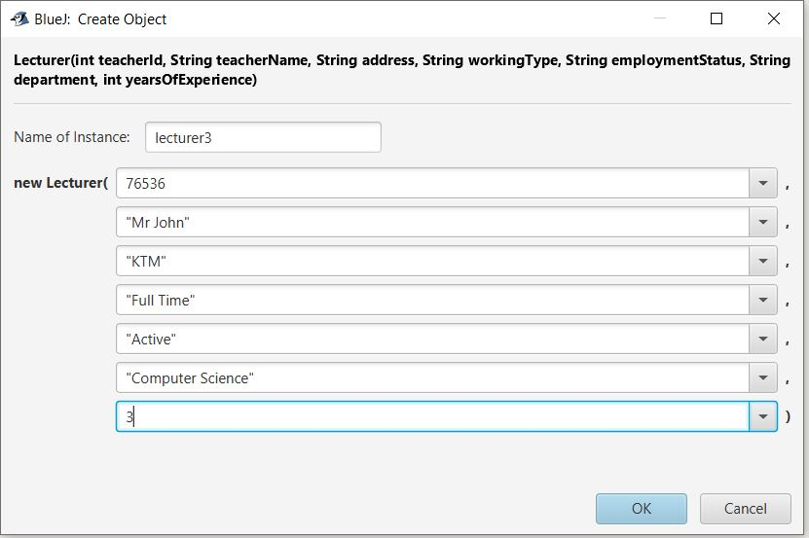Now, we need to create an object and insert the required values.

Figure 5: Inserting values to Lecturer object

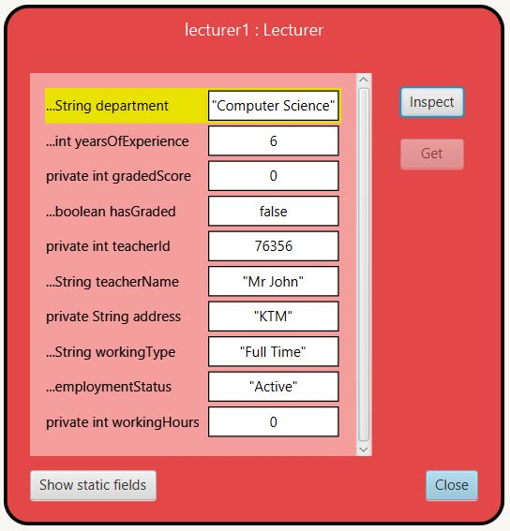

Figure 6: Inspecting the Lecturer Class before setting the GradedScore

• **Setting the Graded Score**

In order to set the Graded, we need to insert the required values. After inserting the values, we need to re-inspect the Lecturer class.

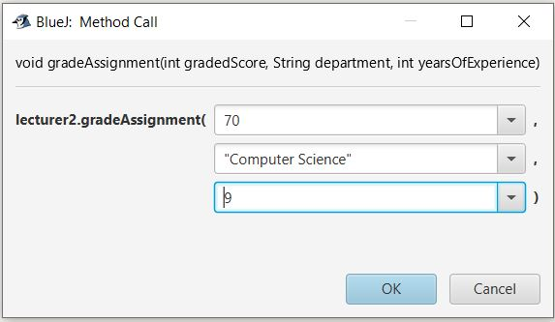

Figure 7: Setting the Graded Score

• **Output after setting the Graded Score**

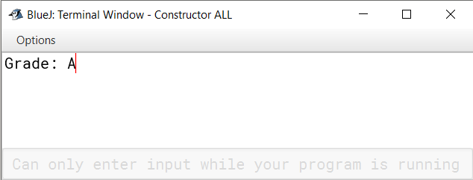

Figure 8: Output after setting the Graded Score

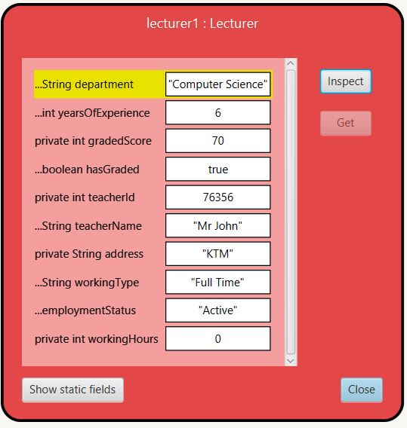

Figure 9: Inspecting the Lecturer Class After setting the GradedScore

## **5.2)** **Test 2:**

• Inspecting the Tutor Class

Table 2: Table of Tutor for test 2

|  |  |
| --- | --- |
| Objective | Inspect the Tutor class object, update salary, and verify the updated salary. |
| Actions | The Tutor Class is assigned the following attributes :  teacherlD = 76356  teacherName = “Mr John”  address = “KTM”  workingType = “Full Time”  employmentStatus = “Active”  workingHours = 25  salary = 2500  specialization = “Professonal”  academicQualifications = “PHD”  performancelndex = 9  The Class is then inspected.  Afterwards, the void setSalary is declared with the following attributes:  newSalary = 50000  newPerformancelndex = 9  The Class is then inspected again. |
| Expected Result | A new salary should appear despite the default salary value entered through the parameter, by adding appraisal to it. Also, the boolean isCertified should also be true. |
| Actual Result | New salary with appraisal appeared and the boolean isCertified was also set to be true |
| Conclusion | Test become successful |

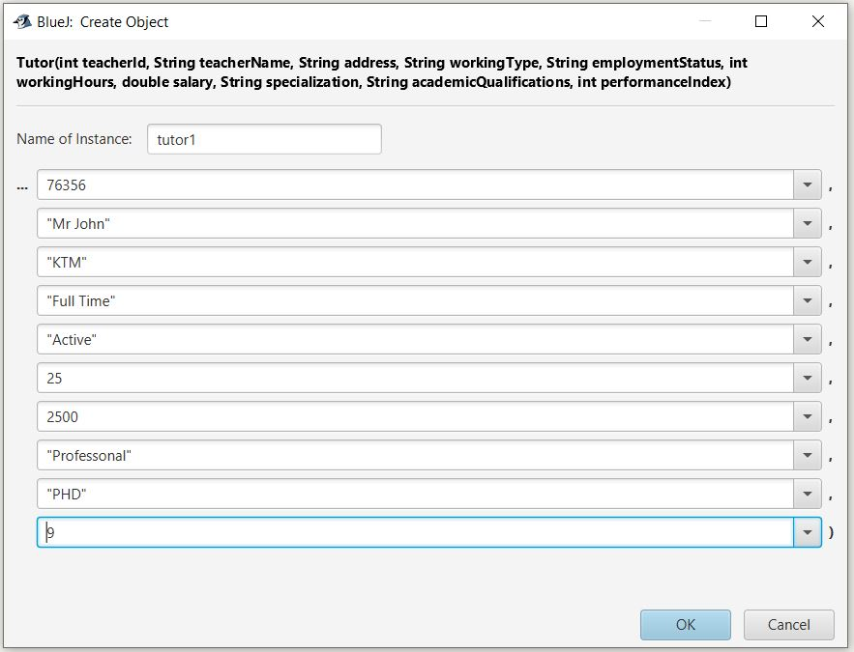• Creating the object of Tutor Class

Figure 10: Inserting values to Tutor object

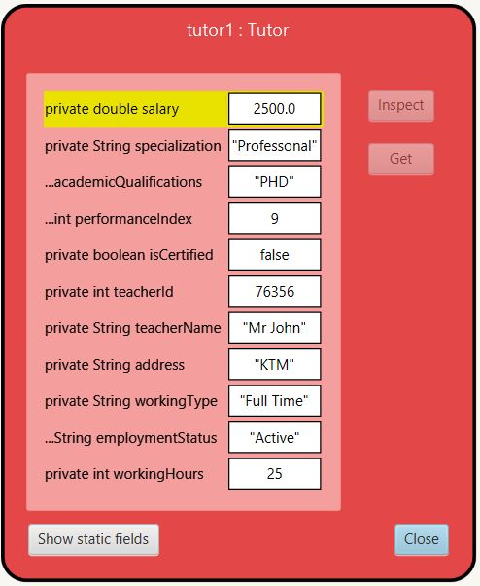• inspecting the Tutor Class before setting salary:-

Figure 11: Inspecting the Tutor class before setting the Salary

• Assigning the Tutor Class for salary:-

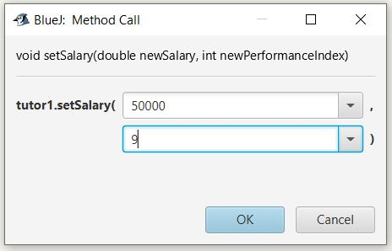

Figure 12: Assigning the Tutor Class for salary

• inspecting the Tutor Class After setting salary:-

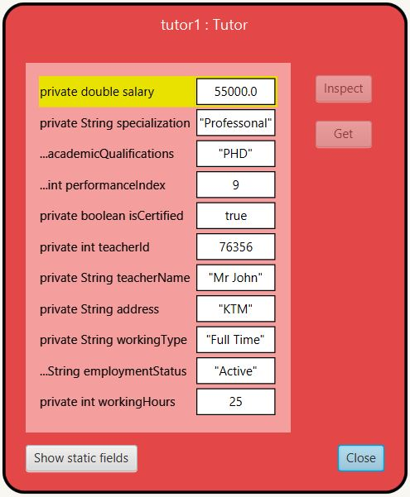

Figure 13: inspecting the Tutor Class After setting salary

## **5.3)** **Test 3:**

• Inspecting the Tutor class for removing Tutor:-

Table 3: Table of Tutor for test 3

|  |  |
| --- | --- |
| Objective | Inspect the Tutor class object, update salary, and verifying the removeTutor. |
| Actions | The Tutor Class is assigned the following attributes :  teacherlD = 76356  teacherName = “Mr John”  address = “KTM”  workingType = “Full Time”  employmentStatus = “Active”  workingHours = 25  salary = 2500  specialization = “Professonal”  academicQualifications = “PHD”  performancelndex = 9  the void removeTutor is declared  The Class is then inspected. |
| Expected Result | A display message displaying that the tutor is removed is expected. Also, upon inspection, some details of the tutor including salary, specialization, academicQualifications and performance index are all set to null values. Also, the certification of the tutor is set to false. |
| Actual Result | Display message received. The details of the tutor are set to null values. Also, the certification of the tutor is set to false. |
| Conclusion | Test become successful |

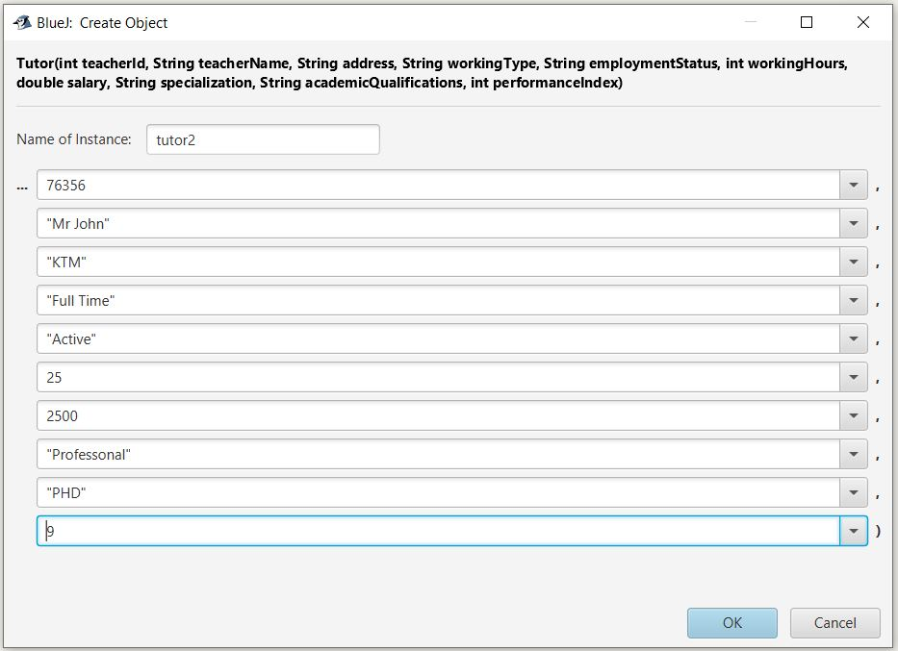• Creating the object of Tutor Class

Figure 14: Creating the object of Tutor Class

• inspecting the Tutor Class before Removing Tutor:-



Figure 15: inspecting the Tutor Class before Removing Tutor

• Message got after running the RemoveTutor method:-

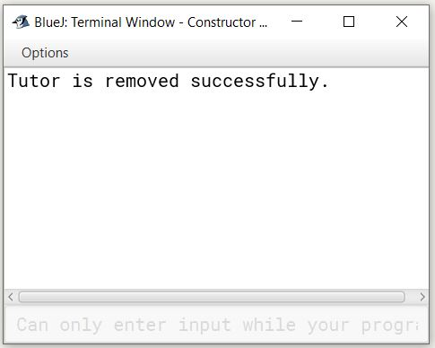

Figure 16: message After running the RemoveTutor method

• Reinspecting the Tutor Class After Removing Tutor:-

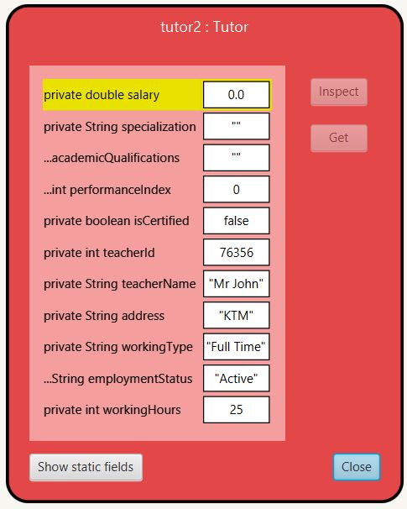

Figure 17: Reinspecting the Tutor Class After Removing Tutor

## **Test 4:**

## **4.1 Displaying the lecturer Class**

Table 4: Table of Lecturer for test 4.1

|  |  |
| --- | --- |
| Objective | To display the details of Lecturer Class |
| Actions | The Lecturer Class is assigned the following attributes :  teacherlD = 76356  teacherName = “Mr John”  address = “KTM”  workingType = “Full Time”  employmentStatus = “Active”  department = “Computer Science”  yearsOfExperience = 7  Then, the void gradeAssignment() method is run to enter the gradeScore, department and years of Experience  as follows :  gradedScore : 70  department : “Computer Science”  yearsOfExperience : 7  After the values are inserted to the attributes, the void display() method is run which displays the  details of the class Lecturer. |
| Expected Result | After the display() method is run, all the details of the Lecturer along with the graded score should be visible in the display. |
| Actual Result | All the details of the Lecturer is seen in the display. |
| Conclusion | Test become successful |

• First of all, we assign values to the parameters of the constructor inside the Lecturer class.

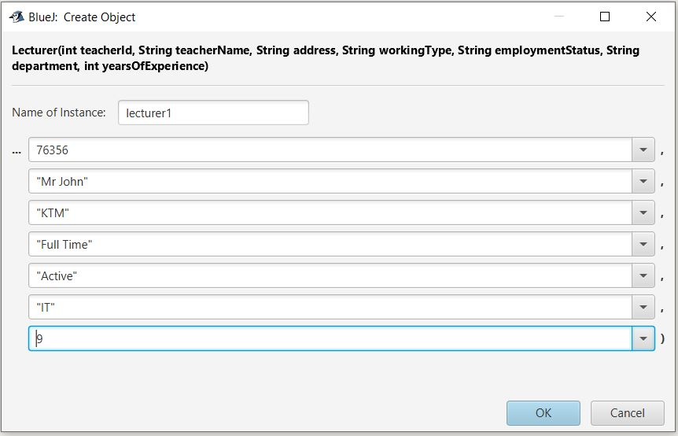

Figure 18: creating object for lecturer

• Then, we run the void gradeAssignment() method to provide grade score along with verifying the department and years of experience of the lecturer.

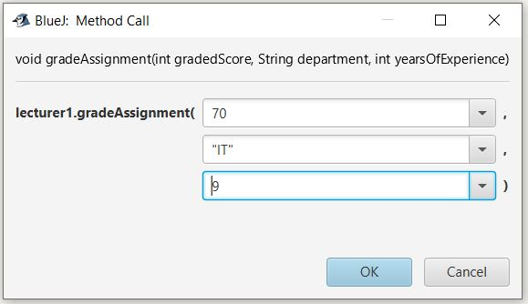

Figure 19: inserting values for gradeAssignment

• Running the display() of lecturer

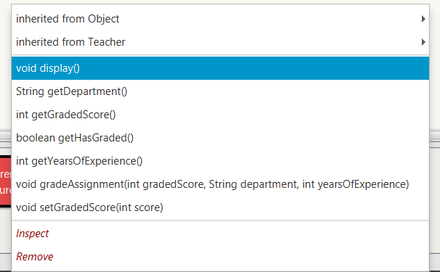

Figure 20: Calling the display() method

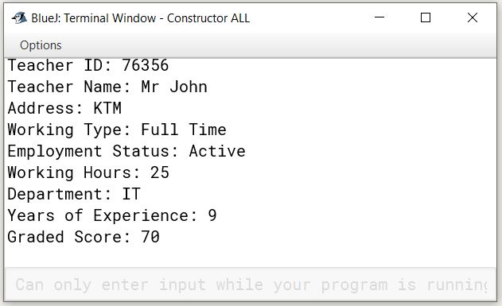• After Running the display() method, following result can be Printed :

Figure 21: Displaying the Lecturer class

## **4.2 Displaying the Tutor Class**

Table 5: Table of Tutor for test 4.2

|  |  |
| --- | --- |
| Objective | To display the details of Tutor Class |
| Actions | The Tutor Class is assigned the following attributes :  teacherlD = 76356  teacherName = “Mr John”  address = “KTM”  workingType = “Full Time”  employmentStatus = “Active”  workingHours = 25  salary = 2500  specialization = “Professonal”  academicQualifications = “PHD”  performancelndex = 9  The Class is then inspected.  Afterwards, the void setSalary is declared with the following attributes:  newSalary = 50000  newPerformancelndex = 9  After the values are inserted to the attributes, the void display() method is run which displays the details of the class Teacher. |
| Expected Result | After the display() method is run, all the details of the Tutor along with the new salary with appraisal should be visible in the display. |
| Actual Result | All the details of the Tutor is seen in the display |
| Conclusion | Test become successful |

• First of all, we assign values to the parameters of the constructor inside the Tutor class.



Figure 22: Creating an object for Tutor class

• Then, we run the void setSalary() method to provide newSalary along with newPerformanceIndex experience of the Tutor.

Figure 23: inserting values for setSalary

• Running the display()

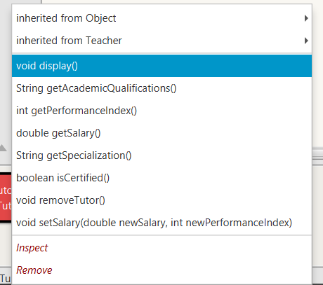

Figure 24: Calling the display() method

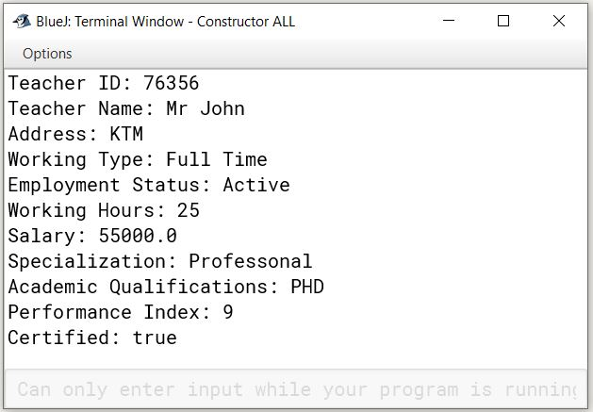• After Running the display() method, following result is Printed:

Figure 25: Displaying the Tutor class

# 6.Error Detection and Error correction

## **6.1 Syntax Error**

A syntax error occurs when the program is not written according to the rules and structure of the Java programming language. (Vyas, 2023) It is the most common error done by coders while writing a program. If there occurs a syntax error, then the code won't work.

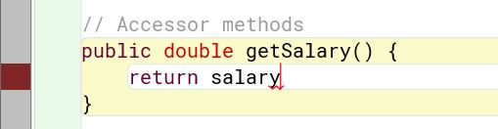Error:

Figure 26: Syntax Error

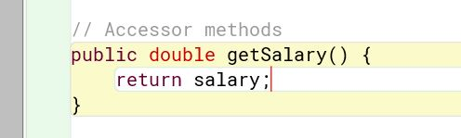Correction:

Figure 27: Syntax Error Correction

## **6.2 Runtime Error**

Runtime error refers to the type of error that occurs when a program encounters an unexpected problem during execution, even if it has no syntax or logical errors. It often causes the program to crash or behave abnormally. (Vyas, 2023)

Example: Here’s an example of the runtime error I encountered while doing this project:

Output of error:

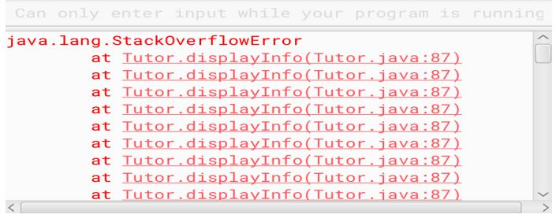

Figure 28: Runtime error detection while execution

Error:

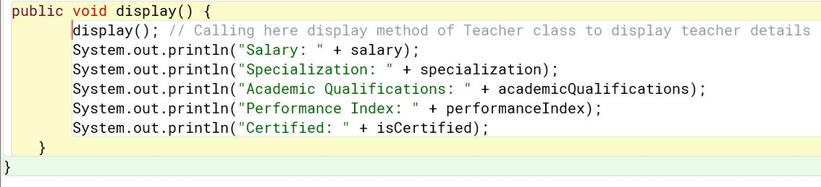

Figure 29: : Runtime Error Detection

In the figure above, in the Tutor class inside the display() method, I initially tried to call the superclass Teacher using just display(). This did not result in any kind of error beforehand; logical or syntax error.

Correct:

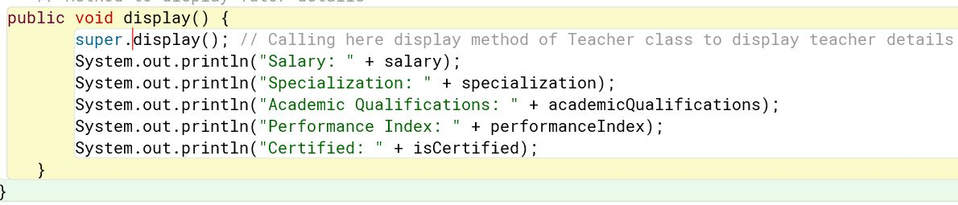

Figure 30: error correction

## **6.3 Logical Error**

Logical error is one of the very common errors made by programmers while writing the code. (Vyas, 2023) It can also be very hard to find because it doesn't prevent the program from compiling, but it can generate unexpected results. To avoid such errors, an individual must be careful while writing the code and must recheck once or twice.

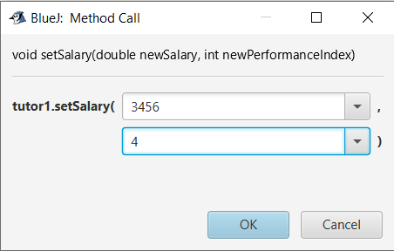Output of error:

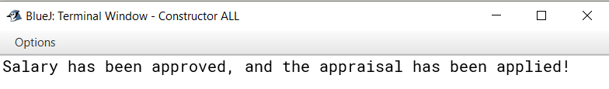

Figure 31: output After the Logical Error

Error:

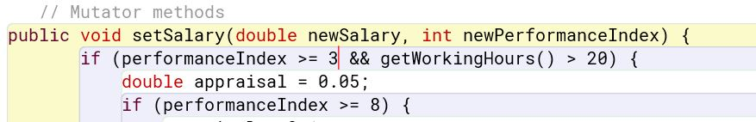

Figure 32: Logical Error

Correction:

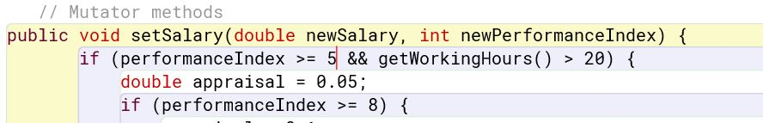

Figure 33: Correction of Logical Error

# 7.Conclusion

The project's completion was smooth but challenging at the same time, as it was the first time for me and everyone else too. We had enough time to finish the coursework, which is why the whole completion was smooth. I believe I did a good job in improving the readability of my code using indentation and comments in the code. Even though it was tough, the journey was worth it. It wasn't just about finishing a task. It was about growing and getting stronger. Dealing with the hard parts, especially the code part, taught me a lot. It wasn't just about grades; I also learned things that go beyond the classroom. Overall, it was like a journey of learning and gaining not just smarts, but also getting tougher.

I learned many new things while doing this coursework. It was very obvious to face some kind of difficulties, as it was a very new thing for the students. However, with the help of the module teachers, friends, and the internet, I was able to complete the coursework on time. I personally had a hard time dealing with the documentation. I am sure everyone hustled day and night for the completion of the coursework, especially the documentation part (for me). But in the end, I got to learn so many things that were new and fruitful for me at the same time.

At last, Completing the project was a big learning experience for me. It was a bit tough because it was something new for everyone. I had enough time to finish the work, and I focused on making my code easy to understand with spaces and comments. Dealing with the hard parts, especially writing about the project, was a challenge, but I learned a lot. With help from teachers, friends, and the internet, I managed to finish on time. Even though it was tough, it was worth it. I not only got better at the project but also became stronger in handling difficulties.

# 7.References

Kölling, M. (2004, october 4). *bluej.org*. Retrieved from bluej: https://www.bluej.org/doc/tutorial.html

Plynko, P. (2022, June 7). *codegym*. Retrieved from codegym: https://codegym.cc/groups/posts/accessors-and-mutators-in-java

Singh, C. (2012). *beginnersbook*. Retrieved from beginnersbook: https://beginnersbook.com/2013/10/hierarchical-inheritance-java-program/

Toulson, R. (2017). *sciencedirect*. Retrieved from sciencedirect: https://www.sciencedirect.com/topics/engineering/pseudocode

Vyas, H. (2023, September 29). *codingninjas*. Retrieved from codingninjas: https://www.codingninjas.com/studio/library/types-of-error-in-java

# 8.Appendix

• **Code for Teacher (Super Class)**

public class Teacher {

// Attributes

private int teacherId;

private String teacherName;

private String address;

private String workingType;

private String employmentStatus;

private int workingHours;

// Constructor

public Teacher(int teacherId, String teacherName, String address, String workingType, String employmentStatus) {

this.teacherId = teacherId;

this.teacherName = teacherName;

this.address = address;

this.workingType = workingType;

this.employmentStatus = employmentStatus;

}

// Accessor methods

public int getTeacherId() {

return teacherId;

}

public String getTeacherName() {

return teacherName;

}

public String getAddress() {

return address;

}

public String getWorkingType() {

return workingType;

}

public String getEmploymentStatus() {

return employmentStatus;

}

public int getWorkingHours() {

return workingHours;

}

// Method to set working hours

public void setWorkingHours(int hours) {

this.workingHours = hours;

}

// Display method

public void display() {

System.out.println("Teacher ID: " + teacherId);

System.out.println("Teacher Name: " + teacherName);

System.out.println("Address: " + address);

System.out.println("Working Type: " + workingType);

System.out.println("Employment Status: " + employmentStatus);

if (workingHours > 0) {

System.out.println("Working Hours: " + workingHours);

} else {

System.out.println("Working Hours have not been assigned yet.");

}

}

}

• **Code for Lecturer(Sub class)**

public class Lecturer extends Teacher {

// Additional attributes for Lecturer

private String department;

private int yearsOfExperience;

private int gradedScore;

private boolean hasGraded;

// Constructor for Lecturer which uses the superclass constructor

public Lecturer(int teacherId, String teacherName, String address,

String workingType, String employmentStatus,

String department, int yearsOfExperience) {

super(teacherId, teacherName, address, workingType, employmentStatus);

this.department = department;

this.yearsOfExperience = yearsOfExperience;

this.gradedScore = 0; // Assign gradedScore as 0

this.hasGraded = false; // Assign hasGraded as false

}

// Accessor methods

public String getDepartment() {

return department;

}

public int getYearsOfExperience() {

return yearsOfExperience;

}

public int getGradedScore() {

return gradedScore;

}

public boolean getHasGraded() {

return hasGraded;

}

// Mutator method for gradedScore

public void setGradedScore(int score) {

this.gradedScore = score;

}

// Method to grade assignments

public void gradeAssignment(int gradedScore, String department, int yearsOfExperience) {

if (yearsOfExperience >= 5&&this.department.equals(department))

{

if (gradedScore < 0 || gradedScore > 100) {

System.out.println("Out of range grading score; it must be between 0 and 100");

} else {

// Grading logic

if (gradedScore >= 70) {

System.out.println("Grade: A");

} else if (gradedScore >= 60) {

System.out.println("Grade: B");

} else if (gradedScore >= 50) {

System.out.println("Grade: C");

} else if (gradedScore >= 40) {

System.out.println("Grade: D");

} else {

System.out.println("Grade: E");

}

this.gradedScore = gradedScore;

this.hasGraded = true;

}

} else {

// Display a suitable message when assignments have already been graded.

System.out.println("Assignments have not graded.");

}

}

// Override the display method to include Lecturer details

@Override

public void display() {

super.display();

System.out.println("Department: " + department);

System.out.println("Years of Experience: " + yearsOfExperience);

if (hasGraded) {

System.out.println("Graded Score: " + gradedScore);

} else {

System.out.println("This Lecturer has not graded any assignment yet.");

}

}

}

**• Code for Tutor(sub class)**

public class Tutor extends Teacher {

// Additional attributes

private double salary;

private String specialization;

private String academicQualifications;

private int performanceIndex;

private boolean isCertified;

// Constructor

public Tutor(int teacherId, String teacherName, String address, String workingType, String employmentStatus,

int workingHours, double salary, String specialization, String academicQualifications, int performanceIndex) {

super(teacherId, teacherName, address, workingType, employmentStatus);

setWorkingHours(workingHours);

this.salary = salary;

this.specialization = specialization;

this.academicQualifications = academicQualifications;

this.performanceIndex = performanceIndex;

this.isCertified = false;

}

// Accessor methods

public double getSalary() {

return salary;

}

public String getSpecialization() {

return specialization;

}

public String getAcademicQualifications() {

return academicQualifications;

}

public int getPerformanceIndex() {

return performanceIndex;

}

public boolean isCertified() {

return isCertified;

}

// Mutator methods

public void setSalary(double newSalary, int newPerformanceIndex) {

if (performanceIndex >= 5 && getWorkingHours() > 20) {

double appraisal = 0.05;

if (performanceIndex >= 8) {

appraisal = 0.1;

} else if (performanceIndex == 10) {

appraisal = 0.2;

}

this.salary = newSalary + (newSalary * appraisal);

this.isCertified = true;

System.out.println("Salary has been approved, and the appraisal has been applied!");

} else {

System.out.println("Tutor cannot be certified yet. Salary cannot be approved.");

}

}

public void removeTutor() {

if (!isCertified) {

salary = 0.0;

specialization = "";

academicQualifications = "";

performanceIndex = 0;

isCertified = false;

System.out.println("Tutor is removed successfully.");

} else {

System.out.println("The tutor is certified. Cannot remove certified tutor.");

}

}

// Method to display Tutor details

public void display() {

super.display(); // Calling here display method of Teacher class to display teacher details

System.out.println("Salary: " + salary);

System.out.println("Specialization: " + specialization);

System.out.println("Academic Qualifications: " + academicQualifications);

System.out.println("Performance Index: " + performanceIndex);

System.out.println("Certified: " + isCertified);

}

}